The Alpha Bounce Shoe
Name:
Professor:
Course title:
Institution:
Date:
The Adidas has used cutting edge technology to come its latest line up of running shoes. The new Alpha bounce shoe shaped using ARAMIS, a motion-capture system which helps to determine the amount of strain and tension caused by different materials. The technique uses high-speed cameras with flexion sensors to gather information at up to 500 frames per second. Since the software maps skin, bone and muscle, it can give Adidas engineers insight into how they should go about designing a more comfortable running sneaker. This inspired the design of the Alpha bounce shoe which is durable, comfortable and affordable.
There is more tech quotient to the shoe which has dictated the entire shoe make over. The upper part of the shoe is made using Forged Mesh and consequently the upper layer is made of a seamless piece. This has differentiated the shoe within the market. The shoe stands out due to its softness and smooth texture.
While it is incredibly lightweight, flexible and comfortable, it is also quite strong with a thick density mesh, providing a secure fit. The amount of cushioning under the foot guarantees comfort. Although it is not like a fluffy shoal but it is kept firm to provide a bit of the spring effect during jogging or running. The new shoes have taken comfort aspect to the next level. They are designed to absorb the jarring impact that tend to get transferred from a hard-running surface to the calf muscles. A lot of runners prefer feedback from the surface they are running on, but we observed that the Alpha Bounce tends to muzzle that a bit. While running, the circle pattern design and the materials used in the outsole provide considerable grip and traction. The following is a bill of the materials that have been used to create the heavenly feel.

BILL OF MATERIALS
PRODUCT NAME | Alpha bounce Shoes | ITEM  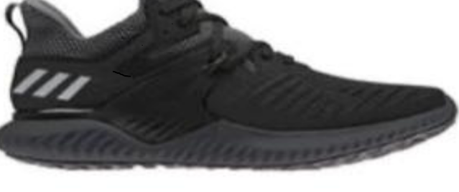
COMPANY | ADIDAS
RETAIL PRICE | $100
PART NUMBER | PART NAME | DESCRIPTION | QUANTITY
1 | Outsole | Continental rubber from heel to toe for extraordinary traction in wet and dry conditions. | 1
2 | Midsole | Made of elastic foam engineered to feel soft and bouncy. | 1
3 | Heel Counter | Fit counter molded heel counter which provides a natural fit that allows optimal movement of the Achilles. | 1
4 | Upper | This is the top part of the shoe. It is made with flexible light weight material: Forged Mesh. Has only a single layer of material for free foot movement and a ribbed pattern that provides both support and expansion when needed. | 1
5 | Inner sole | 4mm thick made of algae-based EVA foam | 1
6 | Rope lace | Multicolored | 1
 |  | TOTAL PARTS | 7

Alpha bounce
Assembly
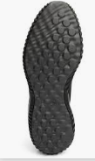
2.Midsole

- Outersole
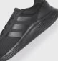
4. Upper
3.Heel counter

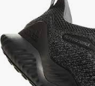
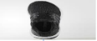
5.Innersole
6. Rope lace
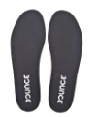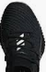

Processing of raw material is a serious of operations that transform industrial materials from a raw-material state to a part or finished products. For Adidas’s footwear industry, the mass production factories convert cottons, leather, polyester, rubber and other materials into partials of shoes by forming, cutting, and shaping according to the design drafts. After assembling all the parts together, workers have to package all finished products and label them. Then all those boxed shoes are ready to be packed to bigger containers and ship worldwide (Robusti, 2017).
Most of the production done by Adidas is outsourced. Adidas works with about 700 independent factories from around the world that manufacture various products in more than 50. The supply chain is global and multi-layered, with many different types of business partners, some of whom are directly contracted factories, while others are not. The top five countries per region by number of supplier sites are Asia which includes China, Vietnam, Korea, Indonesia and India, America particularly United States, Brazil, Argentina, Canada, and El Salvador and the EMEA which comprises of Germany, Turkey, Italy, United Kingdom, and Spain .The table below shoes the raw materials used and their sources:
 | Material | Source | Exact Location | Price
A | Rubber | Thailand, Brazil, Vietnam | Brazil: Avenida Antonio Braga de Azevedo, 407  Thailand: 110 Moo 13, Mitraphab Rd Bantrad, | $8
B | Foam | China | No.888 of AnHua Road | $15
C | Boost | German | Gottlieb-Daimler-Straße 8 | $15
D | Polyurethane | Taiwan | No. 413 Section 2, Ching Yun Road | $7

The following is the supply chain for the new alpha bounce shoes with both the upstream and downstream tiers:
Upstream Downstream
2nd Tier 1st Tier
ARAMIS tech and Bounce manufacturer
Midsole processing
Alpha bounce manufacturer and ARAMIS tech

1st Tier 2nd Tier 3rd Tier
Outsole processing
Rubber manufacturer
Consumers
Rebel Sports
Distribution centres

3
Innersole processing
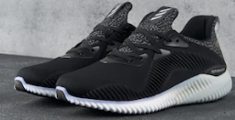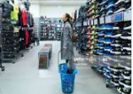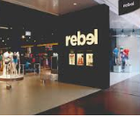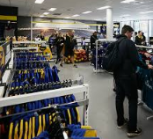
Eva foam manufacturer

Reference
Robusti, G. A. (2017). U.S. Patent Application No. 29/562,507.

